

计算机与信息学院实验报告

实验课程： | 面向对象程序设计实践
实验编号： | 13
实验名称： | 组件及事件处理
实验人员： | 年级 |  | 2018级
实验人员： | 专业 |  | 计算机类
实验人员： | 学号 |  | 18111303044
实验人员： | 姓名 |  | 邵一波
实验日期： | 2019-05-27
上交日期： | 2019-05-27
实 验 室： | 2号实验楼202
实验评价：
 | 实验成绩： |  |  | 评定日期：
 | 指导教师：

- 实验目的
- 掌握图形用户界面编程的一般步骤。
- 掌握Java事件处理方法
- 掌握常用组件使用方法
- 掌握文件的读写方法
二、实验环境
Windows 7,Eclipse+jdk8 ,PC
三、实验内容与步骤
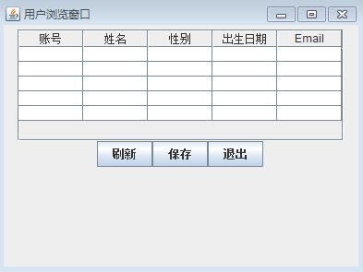
编写程序实现用户注册、显示以及数据保存到磁盘文件。如图13-1、13-2和13-3。
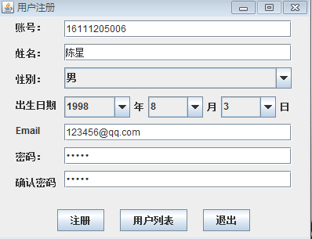
图13-1 用户注册窗口 图13-2 用户浏览及保存窗口

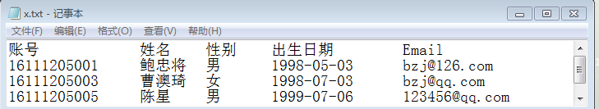
图13-3 文件保存格式

功能要求：
- 在用户注册窗口中输入相应信息后，单击“注册”按钮后完成用户注册功能（用对象数组，实现多个用户注册并存储）。注册成功后，将注册信息在表格中显示。
- 数据合法性验证和焦点切换等要求同实验12，你自己也可以扩展功能。
- 单击“用户列表”显示一个新窗口。在新窗口中用表格组件显示已经注册的用户列表，完成列表（已注册用户）刷新和数据保存到磁盘等功能。

四、实验代码与实验结果及分析
实验代码：
文件 Demo.java
public class Demo {
public static User user[] = new User[1];
public static void main(String args[]) {
UserRegisterWindow win = new UserRegisterWindow();
win.setBounds(100, 100, 450, 350);
win.setTitle("UserRegister");
}
}
文件 User.java
import java.util.*;
public class User {
String userNo;
String userName;
String password;
Date birthday;
short age = 0;
String email;
String userSex;
static int registerCount = 0;
void register(String userNo,String userName,String password,Date birthday,String email,String userSex) {
this.userNo = userNo;
this.userName = userName;
this.password = password;
this.birthday = birthday;
this.email = email;
this.userSex = userSex;
computeAge();
registerCount++;
}
Object[] getInfo() {
Object temp[] = {userNo,userName,userSex,String.format("%tF", birthday),email};
return temp;
}
void computeAge() {
Calendar cal = Calendar.getInstance();
Calendar ca2 = Calendar.getInstance();
cal.setTime(new Date());
ca2.setTime(birthday);
age=(short)(cal.get(Calendar.YEAR)-ca2.get(Calendar.YEAR));
}
static boolean isUserNo(String userNo) {
char no[] = userNo.toCharArray();
if(no.length == 11) return true;
else return false;
}
static boolean isEmail(String email) {
int count=0;
for (int i = 0; i < email.length(); i++) {
char chat = email.charAt(i);
if (chat=='@') {
count++;
}
if (count>1) {
return false;
}
}
int pointIndex=email.lastIndexOf(".");
int aindex=email.indexOf("@");
if (pointIndex<aindex) {
return false;
}
if (aindex+1>=pointIndex) {
return false;
}
if (aindex==0) {
return false;
}
return true;
}
}
文件 UserRegisterWindow.java
import java.util.*;
import java.awt.*;
import java.awt.event.*;
import javax.swing.*;
public class UserRegisterWindow extends JFrame implements ActionListener,ItemListener,KeyListener,FocusListener {
String userNo;
String userName;
String email;
String password1;
String password2;
String userSex;
Date birthday = null;
User userTemp[];
Box boxH_1,boxH_2,boxH_3;
Box boxV_1,boxV_2,boxV_3;
JButton button1 = new JButton("Register");
JButton button2 = new JButton("Cancle");
JButton button3 = new JButton("Users List");
JTextField text1 = new JTextField(10);
JTextField text2 = new JTextField(10);
JTextField text3 = new JTextField(10);
JTextField text4 = new JPasswordField(10);
JTextField text5 = new JPasswordField(10);
JComboBox<String> comBox1 = new JComboBox<String>();
JComboBox<String> comBox2 = new JComboBox<String>();
JComboBox<String> comBox3 = new JComboBox<String>();
JComboBox<String> comBox4 = new JComboBox<String>();
public UserRegisterWindow() {
setLayout(new FlowLayout());
addListener();
init();
setVisible(true);
setDefaultCloseOperation(JFrame.DISPOSE_ON_CLOSE);
}
void addListener() {
//add ActionListener
button1.addActionListener(this);
button2.addActionListener(this);
button3.addActionListener(this);
//add ItemListener
comBox1.addItemListener(this);
comBox2.addItemListener(this);
comBox3.addItemListener(this);
comBox4.addItemListener(this);
//add KeyListener
text1.addKeyListener(this);
text2.addKeyListener(this);
text3.addKeyListener(this);
text4.addKeyListener(this);
text5.addKeyListener(this);
//add FocusListener
text1.addFocusListener(this);
text2.addFocusListener(this);
text3.addFocusListener(this);
text4.addFocusListener(this);
text5.addFocusListener(this);
}
void init() {
//Box Setting
boxH_1 = Box.createHorizontalBox();
boxH_2 = Box.createHorizontalBox();
boxH_3 = Box.createHorizontalBox();
boxV_1 = Box.createVerticalBox();
boxV_2 = Box.createVerticalBox();
boxV_3 = Box.createVerticalBox();
//add to boxV_1
boxV_1.add(Box.createVerticalStrut(3));
boxV_1.add(new JLabel("User Number:"));
boxV_1.add(Box.createVerticalStrut(11));
boxV_1.add(new JLabel("User Name:"));
boxV_1.add(Box.createVerticalStrut(11));
boxV_1.add(new JLabel("User Sex:"));
boxV_1.add(Box.createVerticalStrut(11));
boxV_1.add(new JLabel("Birthday:"));
boxV_1.add(Box.createVerticalStrut(11));
boxV_1.add(new JLabel("Email:"));
boxV_1.add(Box.createVerticalStrut(11));
boxV_1.add(new JLabel("Password:"));
boxV_1.add(Box.createVerticalStrut(11));
boxV_1.add(new JLabel("Password(again):"));
//add to boxV_2
boxV_2.add(text1);
boxV_2.add(Box.createVerticalStrut(5));
boxV_2.add(text2);
boxV_2.add(Box.createVerticalStrut(5));
boxV_2.add(comBox1);
boxV_2.add(Box.createVerticalStrut(5));
boxV_2.add(boxH_1);
boxV_2.add(Box.createVerticalStrut(5));
boxV_2.add(text3);
boxV_2.add(Box.createVerticalStrut(5));
boxV_2.add(text4);
boxV_2.add(Box.createVerticalStrut(5));
boxV_2.add(text5);
//add to boxV_3
boxV_3.add(boxH_2);
boxV_3.add(Box.createVerticalStrut(25));
boxV_3.add(boxH_3);
//add to boxH_1
boxH_1.add(comBox2);
boxH_1.add(new JLabel("Year"));
boxH_1.add(comBox3);
boxH_1.add(new JLabel("Mouth"));
boxH_1.add(comBox4);
boxH_1.add(new JLabel("Day"));
//add to boxH_2
boxH_2.add(boxV_1);
boxH_2.add(Box.createHorizontalStrut(10));
boxH_2.add(boxV_2);
//add to boxH_3
boxH_3.add(button1);
boxH_3.add(Box.createHorizontalStrut(75));
boxH_3.add(button3);
boxH_3.add(Box.createHorizontalStrut(75));
boxH_3.add(button2);
//add to comBox
comBox1.addItem("Male");
comBox1.addItem("Female");
for(int i = 1900;i<=2050;i++) {
comBox2.addItem(String.valueOf(i));
}
for(int i = 1;i<=12;i++) {
comBox3.addItem(String.valueOf(i));
}
for(int i = 1;i<=31;i++) {
comBox4.addItem(String.valueOf(i));
}
//add
add(boxV_3);
}
void newWindow() {
NewWindow newWin = new NewWindow();
newWin.setBounds(150, 150, 550, 400);
newWin.setTitle("User browsing window");
}
void regist() {
Calendar c = Calendar.getInstance();
c.set(Integer.parseInt(comBox2.getSelectedItem().toString()),
Integer.parseInt(comBox3.getSelectedItem().toString())-1,
Integer.parseInt(comBox4.getSelectedItem().toString()));
birthday = c.getTime();
userNo = text1.getText();
userName = text2.getText();
email = text3.getText();
password1 = text4.getText();
password2 = text5.getText();
if(password1.equals(password2)) {
userTemp = new User[User.registerCount+1];
for(int i = 0;i < Demo.user.length;i++) {
userTemp[i] = Demo.user[i];
}
Demo.user = userTemp;
Demo.user[User.registerCount] = new User();
Demo.user[User.registerCount].register(userNo, userName, password1, birthday, email, userSex);
text2.setText(null);
text3.setText(null);
text4.setText(null);
text5.setText(null);
text1.requestFocus();
JOptionPane.showMessageDialog(boxV_3, "Registration Successful!("+userName+":"+User.registerCount+")", "tip",JOptionPane.PLAIN_MESSAGE);
}
else {
JOptionPane.showMessageDialog(boxV_3, "Registration Failed!("+userName+")", "tip",JOptionPane.PLAIN_MESSAGE);
text4.requestFocus();
text5.setText(null);
}
}
//ActionListener
public void actionPerformed(ActionEvent e) {
if(e.getSource() == button1) {
regist();
}
if(e.getSource() == button2) {
dispose();
}
if(e.getSource() == button3) {
newWindow();
}
}
//ItemListener
public void itemStateChanged(ItemEvent e) {
if(e.getSource() == comBox1) userSex = comBox1.getSelectedItem().toString();
if(e.getSource() == comBox3) {
comBox4.removeAllItems();
int month_temp = Integer.parseInt(comBox3.getSelectedItem().toString());
int day_temp = 31;
if (month_temp == 4 || month_temp == 6 || month_temp == 9 || month_temp == 11) day_temp = 30;
else if (month_temp == 2) {
int year_temp = Integer.parseInt(comBox2.getSelectedItem().toString());
if (year_temp % 400 == 0 || (year_temp % 4 == 0 && year_temp % 100 != 0)) day_temp = 29;
else day_temp = 28;
}
for (int j = 0; j < day_temp; j++) {
comBox4.addItem("" + (j + 1));
}
}
}
//KeyListener
public void keyPressed(KeyEvent e) {
if(e.getKeyCode() == KeyEvent.VK_ENTER) {
if(e.getSource() == text1) {
if(User.isUserNo(text1.getText())) text1.transferFocus();
else {
JOptionPane.showMessageDialog(boxV_3, "Account Format Error!", "Warning",JOptionPane.WARNING_MESSAGE);
text1.setText(null);
}
}
else if(e.getSource() == text3) {
if(User.isEmail(text3.getText())) text3.transferFocus();
else {
JOptionPane.showMessageDialog(boxV_3, "Email Format Error!", "Warning",JOptionPane.WARNING_MESSAGE);
text3.setText(null);
}
}
else if(e.getSource() == text5) {
regist();
}
else {
JTextField t = (JTextField)e.getSource();
t.transferFocus();
}
}
}
public void keyReleased(KeyEvent e) {}
public void keyTyped(KeyEvent e) {}
//FocusListener
public void focusGained(FocusEvent e) {
JTextField t = (JTextField)e.getSource();
t.setText(null);
}
public void focusLost(FocusEvent e) {}
}
文件 NewWindow.java
import java.io.*;
import java.awt.*;
import java.awt.event.*;
import javax.swing.*;
public class NewWindow extends JFrame implements ActionListener{
File userFile;
FileWriter tofile;
BufferedWriter out;
Box boxV,boxH_1,boxH_2;
JButton button1 = new JButton("Refresh");
JButton button2 = new JButton("Save");
JButton button3 = new JButton("Cancle");
Object cellData[][] = {{"null","null","null","null","null","null"}};
Object headers[] = {"User Number","User Name","Sex","Birthday","Email"};
JTable table = new JTable(cellData,headers);
public NewWindow(){
setLayout(new FlowLayout());
init();
setVisible(true);
setDefaultCloseOperation(JFrame.DISPOSE_ON_CLOSE);
}
void addListener() {
button1.addActionListener(this);
button2.addActionListener(this);
button3.addActionListener(this);
}
void wirte() {
try {
File desktopDir = javax.swing.filechooser.FileSystemView.getFileSystemView().getHomeDirectory();
String desktopPath = desktopDir.getAbsolutePath();
userFile = new File(desktopPath,"userInfo.txt");
tofile = new FileWriter(userFile);
out = new BufferedWriter(tofile);
out.write("User Number\tUser Name\tSex\tBirthday\t\tEmail\t\n");
for(int i = 0;i < User.registerCount;i++) {
for(int j = 0;j < 5;j++) {
out.write((String)cellData[i][j]+"\t");
if(j == 1) out.write("\t");
}
out.write("\n");
}
out.close();
tofile.close();
JOptionPane.showMessageDialog(boxV, "Save Successful!","tip",JOptionPane.PLAIN_MESSAGE);
}
catch(IOException e) {
JOptionPane.showMessageDialog(boxV, "Error!", "Warning",JOptionPane.WARNING_MESSAGE);
}

}
void init() {
setLayout(new FlowLayout());
setVisible(true);
addListener();
setDefaultCloseOperation(JFrame.DISPOSE_ON_CLOSE);
boxV = Box.createVerticalBox();
boxH_1 = Box.createHorizontalBox();
boxH_2 = Box.createHorizontalBox();
add(boxV);
boxV.add(boxH_1);
boxV.add(boxH_2);
setColumnWidth(table,headers);
boxH_1.add(new JScrollPane(table) {
public Dimension getPreferredSize() {return new Dimension(495, 300);}
}
);
boxH_2.add(button1);
boxH_2.add(button2);
boxH_2.add(button3);

}
void setColumnWidth(JTable t ,Object h[]) {
t.getColumn(h[0]).setPreferredWidth(90);
t.getColumn(h[1]).setPreferredWidth(90);
t.getColumn(h[2]).setPreferredWidth(45);
t.getColumn(h[3]).setPreferredWidth(90);
t.getColumn(h[4]).setPreferredWidth(180);
}
public void actionPerformed(ActionEvent e) {
if(e.getSource() == button1) {
cellData = new Object[User.registerCount][5];
for(int i = 0;i < User.registerCount;i++) {
cellData[i] = Demo.user[i].getInfo();
}
table = new JTable(cellData,headers);
boxH_1.removeAll();
setColumnWidth(table,headers);
boxH_1.add(new JScrollPane(table) {
public Dimension getPreferredSize() {return new Dimension(495, 300);}
}
);
revalidate();
}
if(e.getSource() == button2) {
wirte();
}
if(e.getSource() == button3) {
dispose();
}
}
}
实验结果及分析：
（详见图一到图十一）
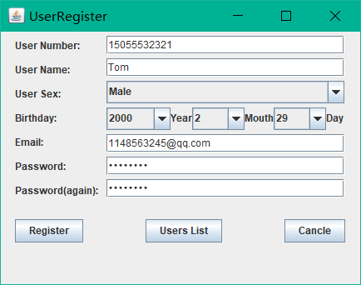
图一 用户注册界面

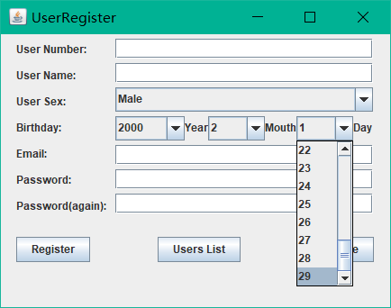
图二 日期格式1

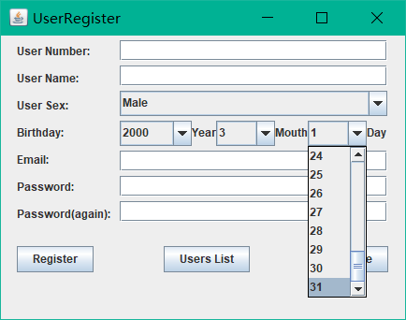
图三 日期格式2

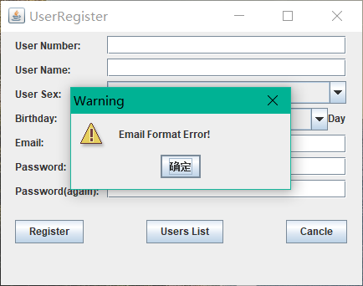
图四 邮箱格式错误处理
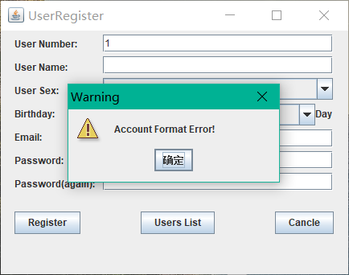
图五 账号格式错误处理

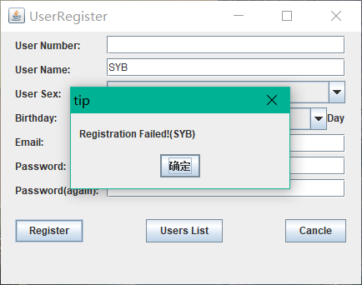
图六 两次密码不同，注册失败
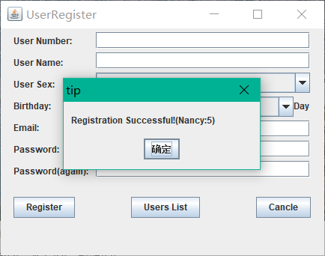
图七 注册成功

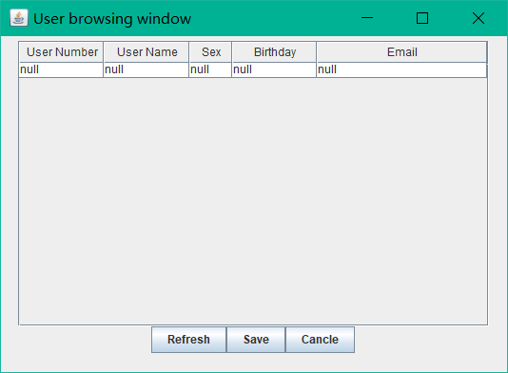
图八 列表初始化
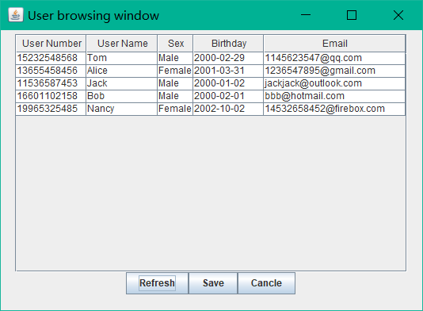
图九 列表刷新

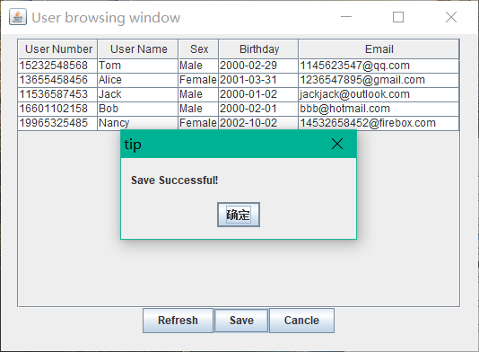
图十 文件保存成功
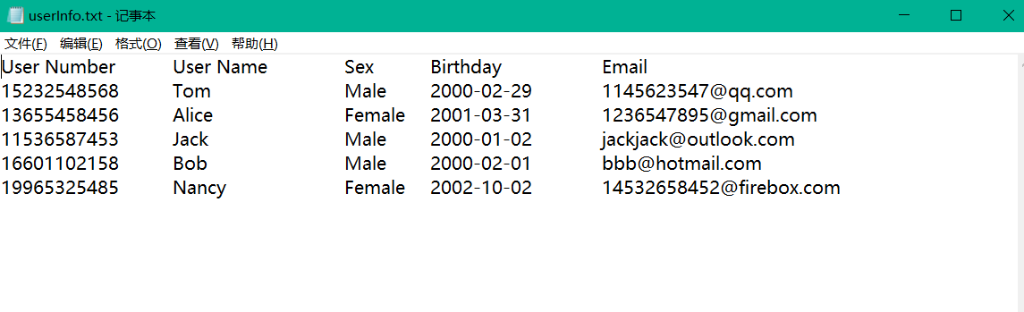
图十一 用户信息文件展示

五、实验总结
- 本次实验圆满完成既定的实验要求；
- 加入了对闰年，非闰年，大月，小月的格式设置；
- 利用动态数组储存用户数据，提高效率；
- 增加提示窗口，提高用户体验；
- 在用户信息预览中，对不同的项目进行了列宽优化（性别，邮箱）；
- 增加文本框自动清空功能
- 注册完成后自动清空之前的用户输入内容；
- 在格式错误时，经提示框提醒，并添加焦点后，自动清空格式错误的内容；
- 添加了应对不同计算机用户，获取其桌面的方法（将用户信息文件保存在桌面）。

